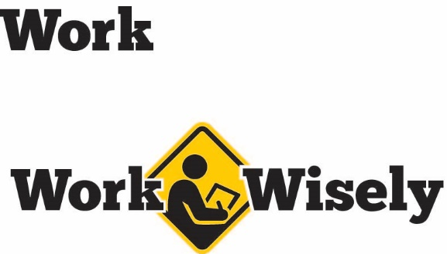
A mini training session for injury prevention
Quick Take on Safety

Deer-vehicle Collisions
TRAINING OVERVIEW AND OBJECTIVES
Overview: This training discusses methods to avoid and safely encounter deer.
Purpose: This talk is designed to remind employees about methods to avoid deer while driving and how to maintain control of the vehicle when encountering deer.
Preparation: Read and become familiar with this Quick Take. Change as needed to reflect procedures and personnel in your department.
Handouts: Quick Review of Safety—Deer-vehicle Collisions

Deer-vehicle Collisions
According to the Minnesota Department of Public Safety, from 2013 through 2015, there were 6,149 deer-vehicle crashes. These resulted in 15 fatalities and 944 injuries. [Instructor Prompt: Ask the audience to describe if they have hit or almost hit a deer, it’s a pretty common occurrence. If no one responds, perhaps ask if they know someone who has hit a deer.]
We can’t avoid all deer-vehicle collisions, but we can avoid many of them. We can greatly reduce injuries with proper preparation and learning the prevention techniques, which we will talk about. Your health and safety is important to us, we don’t want you to get hurt.
Prevention and Best Practices
- Deer-vehicle collisions peak in late October through November, coinciding with deer mating season and diminished daylight hours. Be especially vigilant at this time.
- Increase awareness at dusk and dawn. This is the time when deer are most active.
- Avoid speeding.
- Scan roadside ditches for deer, particularly in forested areas, near river or stream banks, or where deer crossing signs are posted.
- Deer are known to travel in groups and often move in single file. If you see one deer, be especially cautious. It is likely there will be more.
- Deer can be unpredictable. Always slow down when you see deer. They may jump out into the roadway.
- Keep the windshield clean.
- Always buckle up, stay alert and drive sober.
- Use high beams at night or when driving in low-light conditions while being considerate of other drivers.
- Do not drive faster than the time it would take you to stop should something appear in the headlights.
- Go slowly around blind corners or dips and hills on the road where the view ahead is limited.
- Car-mounted deer whistles are largely ineffective at preventing deer strikes. Do not rely on them.

If You Are About to Hit a Deer
- Keep your hands on the wheel.
- Do not swerve. Swerving to avoid a deer can lead to a loss of control. It can also put you and others in the vehicle with you into the path of oncoming traffic or a roadside object.
Hitting the deer is often the safest option.

After Hitting a Deer
- Brake firmly and come to a controlled stop.
- Move well off the roadway.
- Seek medical attention if necessary.
- Turn on the vehicle hazard lights.
- Alert the nearest law enforcement agency to report the collision.
- Do not move the deer yourself. The task may be dangerous due to traffic or the weight and awkward lifting required when moving the animal.
Follow the established personal insurance or employer coverage reporting process. [Instructor prompt- Discuss your organization’s accident reporting process.]

DISCUSSION QUESTIONS
- How can we best avoid injuries from deer-vehicle collisions?
This document is intended for general purposes only and should not be construed as legal or coverage advice on any specific matter.
Developed and provided by Minnesota Counties Intergovernmental Trust


Deer-vehicle Collisions Session
Planning and Review
Trainer |  | Training Date
Department(s)

TRAINING GOALS
- Employees understand the hazards of deer-vehicle collisions.
- Employees know and practice methods to reduce the risk of a collision.
- Employees follow the methods to reduce the risk of an injury in the event of a collision.
RESOURCES
- Minnesota Counties Intergovernmental Trust, “Deer-vehicle Collisions: Take Steps to Reduce Accidents,” MCIT.org
- Minnesota Counties Intergovernmental Trust, Deer-vehicle collision awareness posters, set of three to increase awareness, best used October through November and then removed until next season, MCIT.org
- Minnesota Department of Transportation, “November Is Peak Month for Deer-vehicle Crashes,” DOT.state.mn.us
- Insurance Institute for Highway Safety, Highway Loss Data Institute. “Fatal Crashes with Deer Jump in November.” IIHS.org
REVIEW
Did the training meet the stated goals?
How can the training be improved?
TRAINER COMMENTS

Attendance Record
Training Session | Deer-vehicle Collisions
Trainer |  | Training Date

Participant Name (printed) | Participant Signature

