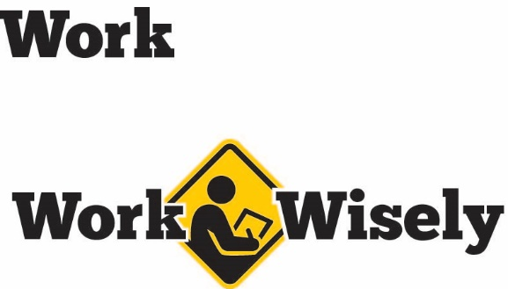
A mini training session for injury prevention
Quick Take on Safety

Office Housekeeping
TRAINING OVERVIEW AND OBJECTIVES
Overview: Discusses hazards related to poor office housekeeping and tips to improve office housekeeping.
Purpose: Refreshes employees about the hazards of poor housekeeping and methods to address them before injuries develop.
Preparation: Read and become familiar with this Quick Take. Change as needed to reflect procedures and personnel in your department.
Handouts: Quick Review of Safety—Office Housekeeping

Housekeeping Hazards
Housekeeping refers to the cleanliness and order of a workplace. When our workplace is untidy, numerous hazards can be created.
- Slips, trips and falls are the most common accidents stemming from poor housekeeping.
- Other hazards include an increased risk of fire, blocked exits or hallways, collisions with objects and falling objects.
Maintaining Good Housekeeping
Good housekeeping is the result of our daily efforts. The work of maintaining a clean and orderly work environment never ends. All of us share the responsibility for keeping the workplace clean and being mindful of housekeeping throughout the day.
Office hazards create risk but with proper preparation and an understanding of prevention techniques, we can avoid or control these risks. Your health and safety are important to us; we don’t want you to get hurt.

Housekeeping Tips and Best Practices
- Keep all walkways and door exits clear. Obstructions may create tripping hazards and hinder evacuations.
- Do not stack items near doorways or in closets. Stacked items may prevent doors from opening and can also increase the risk of falling objects.
- Try to minimize loose papers and materials on floors to reduce tripping and fire hazards.
- Pay attention to where you place items such as brief cases, backpacks or boxes so that they do not become a tripping hazard.
- Whenever possible, store materials on shelves to keep them off of the floor.
- Close all drawers or cabinets after use. When left open, they could become a tripping hazard.
- Keep electrical cords out of areas of traffic. If that is not possible, cover cords to prevent tripping or damage to the cords or equipment. When repositioning cords, avoid using staples or nails that could damage the insulation of the cords.
- Occasionally look under your workstation. Cords and plugs have a habit of creeping forward and catching a foot. In addition to tripping, it may damage equipment when pulled. Tidy up cords and move them away from feet. [Instructor prompt: If a roll of Velcro is available, cut off a small length and hand to employees. They can use this to quickly wrap around cords under desks to keep them tidy]
- Floors, carpets and entry rugs should be monitored for signs of wrinkling and damage and addressed as issues develop. Entry mats or rugs in particular often become saturated with water or develop curling edges or wrinkles leading to slip, trip and fall hazards.
- Stairways should always be kept clear. Items should not be stored on stairs or in stairways, even on a temporary basis.
- Clean up any spills or messes immediately. Spills often occur around coffee makers, water dispensers, sinks or other areas near water. Cleaning up after yourself reduces slip, trip and fall hazards and is just good manners.
- Do not try to clean up blood or other unknown liquids or items by yourself unless it is considered part of your job duties and you know how to proceed safely. [Instructor prompt: Educate employees on how to report and respond to blood or unknown spills and other spills they do not feel comfortable addressing.]
- Report burned out light bulbs quickly. Poor lighting increases the risk of tripping over unseen items.
- Fire extinguishers, sprinklers, first-aid stations and electrical panels must be left unobstructed.
- Electrical panels must have at least 36 inches of clearance in front and 30 inches wide or the width of the panel, whichever is larger.
- Avoid storing items in boiler or mechanical rooms. These rooms contain equipment, electrical breaker panels or other devices that require clear space around them so staff can tend to the equipment. Storing items in these rooms can delay emergency response and increase fire and tripping risks.
- Don’t place combustibles near baseboard or portable heaters. Doing so increases the risk of fires and disrupts air circulation.
- Return all items to their proper locations after use. If you aren’t sure where something goes, ask.
- When items are stacked, ensure the material is stable and will not collapse or shift.
- Avoid storing items that protrude into walkways. If unavoidable reduce the hazard with cushioning, flagging or other means.
- Keep the area around air vents clear. Obstructions disrupt airflow.
- Put trash in appropriate containers. Don’t leave garbage around your workstation or other locations.
- Decaying and moldy food is of particular concern in break rooms and should be removed promptly.
- Appliances should be cleaned periodically.

DISCUSSION QUESTIONS
- How can we keep our workplace consistently clean?
- How can we increase accountability for housekeeping among our staff?
ADDITIONAL ACTIVITY
- Take a little time and have employees do a short safety check of the office and their own workstations. If any hazards are found and cannot safely be remedied, compile a list and send to the appropriate personnel or the safety committee.

This document is intended for general purposes only and should not be construed as legal or coverage advice on any specific matter.
Developed and provided by Minnesota Counties Intergovernmental Trust


Office Housekeeping Session Planning and Review
Trainer |  | Training Date
Department(s)

TRAINING GOALS
- Employees understand the importance of housekeeping.
- Employees know that good housekeeping is everyone’s responsibility.
- Employees are aware of the best practices and methods to achieve and maintain good housekeeping in the office.
RESOURCES
- Minnesota Counties Intergovernmental Trust, Step Wisely slip, trip and fall awareness and prevention materials,MCIT.org
- Occupational Safety and Health Administration, Walking-working Surfaces Standard 1910.22, OSHA.gov
REVIEW
Did the training meet the stated goals?
How can the training be improved?
TRAINER COMMENTS

Attendance Record
Training Session | Office Housekeeping
Trainer |  | Training Date

Participant Name (printed) | Participant Signature

