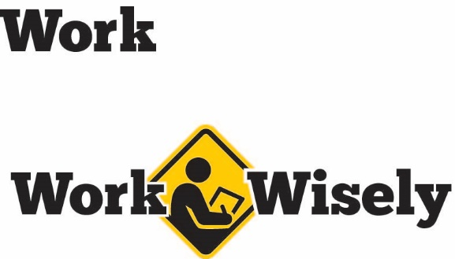
A mini training session for injury prevention
Quick Take on Safety

Office Work Space Ergonomics
TRAINING OVERVIEW AND OBJECTIVES
Overview: Discusses how to use ergonomic best practices to adjust components of an employee’s work space for better fit and comfort, and help reduce potential injury.
Purpose: Refreshes employees about the importance of ergonomics and to encourage them to adjust their workstations to be more comfortable.
Preparation: Read and become familiar with this Quick Take. Change as needed to reflect procedures and personnel in your department.
Handouts: “Your Guide to a Comfortable Workstation” pamphlet. Request pamphlets by contacting MCIT at 1.866.547.6516 or info@mcit.org.

Work Space Ergonomics
How we use our work space and where we position office equipment can help make us more comfortable and help reduce potential strains. Over time, performing tasks at a workstation that is not adjusted to your individual needs could lead to strains or other injuries to muscles and tendons. Once injured, you are much more likely to reinjure the area in the future.
Fortunately, by focusing on how you perform tasks and position equipment, you can minimize strain and awkward body movements, so pay careful attention. Your health and safety is important to us; we don’t want you to get hurt.
Prevention
An important element of ergonomics in the workplace is a neutral posture. Neutral postures are those that improve natural support while placing minimal stress on the body and joints. We will focus on ways to maintain neutral postures and body movements when performing tasks at your workstation.
[Instructor prompt: Have employees take a moment and think about their work space and how computer equipment, their phone and other items on their desktops are positioned.]

MONITORS
- Consider the way your monitors are positioned. Imagine a straight line from the middle of your body through the middle of your keyboard to the area of the monitors you view the most. You should position monitors based on your use. If you have two monitors and use them equally, the space between the monitors should be in line with your nose (see 50-50 image). If you use one monitor more than another, position the most viewed monitor more directly in front of you to minimize head and neck turning (see 30-70 image).
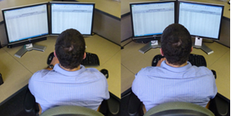
50-50 arrangement 30-70 arrangement

- For widescreen monitors, the top of the screen should be at or slightly below eye level. Full-screen monitors, depending on their height, can be positioned lower. If you wear corrective lenses, adjust the height of the monitors so your clearest field of vision is focused on the area approximately one-third of the way down from the top of the screen while your head is looking forward and not tilted up or down.
- Position monitors at a comfortable reading distance to avoid leaning forward or squinting to read.
- If you have difficulty viewing the screen, adjust the brightness and/or contrast until comfortable.
- If you have glare from lighting above or behind you, try tilting the monitor to reposition the glare away from your eyes.
KEYBOARD AND MOUSE
- Position the keyboard so that your elbows are near your sides and at about a 90 degree angle when typing.
- Your forearms should be parallel with the floor and your wrists straight. [Instructor note: If employees cannot keep wrists straight or are resting them against the hard edge of the desk, a keyboard wrist rest may be placed in front of the keyboard to help keep wrists cushioned and straight]
- Your mouse should be positioned at approximately the same level as the keyboard. Try not to reach when using your mouse. Try to keep your elbow near your side.
- If you have two or more monitors, you may want to increase the speed of your mouse pointer to reduce the amount of movement in your wrist as you use it.
OTHER EQUIPMENT
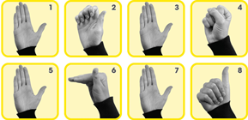
Stretches for the hand and wrist
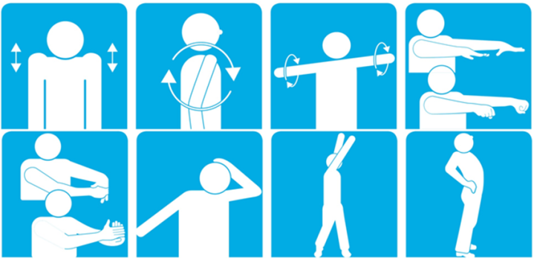
Stretches for the body
- Other equipment used frequently, such as the phone, adding machine, scanner or other equipment, should be placed close to your body and near your dominant hand. This helps to minimize reaching and twisting.
- If you need to look back and forth between a printed document and your screen, use an adjustable document holder. Place it between the screen and keyboard or to the left or right of the screen you are using to minimize twisting and turning of your head and neck.
GENERAL
- Make sure there is room under your desk to allow your chair to pull forward and for you to sit straight on with your keyboard and monitor(s).
- Use all equipment available, such as headsets, foot rests and document stands, as needed.
- Take frequent breaks as necessary. Take this time to stretch and bring blood back to your muscles (see images for stretches). As with any exercise, stop if you feel pain. If discomfort or injury develops, stop immediately and report the incident to a supervisor or management.

DISCUSSION QUESTIONS
- How can you adjust your workstation to be more comfortable?
- Which workstation activities present the greatest ergonomic risks and how can we address them?
ADDITIONAL ACTIVITY
- Lead the group in a selection of stretches. Begin by emphasizing safety.

This document is intended for general purposes only and should not be construed as legal or coverage advice on any specific matter.
Developed and provided by Minnesota Counties Intergovernmental Trust


Office Work Space Ergonomics Session Planning and Review
Trainer |  | Training Date
Department(s)

TRAINING GOALS
- Employees are aware of and know the best ergonomic practices when performing tasks at their workstations.
RESOURCES
- Minnesota Counties Intergovernmental Trust, “Your Guide to a Comfortable Workstation” pamphlet: Request copies at no cost from MCIT at 1.866.547.6516 or info@mcit.org.
- Occupational Safety and Health Administration, Computer Workstations E-tool: OSHA.gov
REVIEW
Did the training meet the stated goals?
How can the training be improved?
TRAINER COMMENTS

Attendance Record
Training Session | Office Work Space Ergonomics
Trainer |  | Training Date

Participant Name (printed) | Participant Signature

