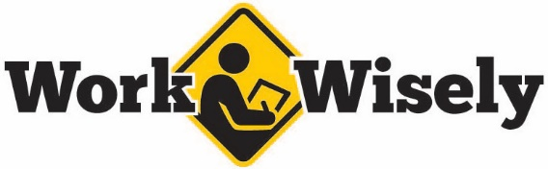
injury prevention
Quick Review of Safety
Utility Knife Safety
- Use a sharp blade. Dull blades require more pressure and increase the risk of slippage or other potential injuries, including ergonomic strain.
- Use safety knives with rounded tips or self-retracting blades wherever possible.
- Plan the cut before cutting, and keep your eye on the blade throughout the process. Keep your hands or extremities out of the path of the blade.
- Inspect the tool before use to ensure that the blade is in its proper position and undamaged.
- Wear safety glasses to protect against broken blades.
- Extend the blade as short as necessary to make the cut.
- Cut away from your body rather than pulling toward you.
- Do not try to force the blade if it becomes stuck.
- Hand knives to others handle first with the blade retracted.
- Store the knife with the blade fully retracted.
- Use the knife for the intended purpose; it is designed to pry objects.
- Dispose of old blades in a puncture-resistant container.
- Breakaway blade models are not designed for heavy-duty industrial use and should not be used for heavy work.
- Change blades carefully according to manufacturer recommendations with the correct size of blades.
- Use the right knife for the job or for your hand, particularly if using the knife for a long time. Knives that are too short can put uncomfortable pressure points into the palm of the hand, while larger knives can be unwieldy to use.
(Over)
injury prevention
Quick Review of Safety
Utility Knife Safety
- Use a sharp blade. Dull blades require more pressure and increase the risk of slippage or other potential injuries, including ergonomic strain.
- Use safety knives with rounded tips or self-retracting blades wherever possible.
- Plan the cut before cutting, and keep your eye on the blade throughout the process. Keep your hands or extremities out of the path of the blade.
- Inspect the tool before use to ensure that the blade is in its proper position and undamaged.
- Wear safety glasses to protect against broken blades.
- Extend the blade as short as necessary to make the cut.
- Cut away from your body rather than pulling toward you.
- Do not try to force the blade if it becomes stuck.
- Hand knives to others handle first with the blade retracted.
- Store the knife with the blade fully retracted.
- Use the knife for the intended purpose; it is designed to pry objects.
- Dispose of old blades in a puncture-resistant container.
- Breakaway blade models are not designed for heavy-duty industrial use and should not be used for heavy work.
- Change blades carefully according to manufacturer recommendations with the correct size of blades.
- Use the right knife for the job or for your hand, particularly if using the knife for a long time. Knives that are too short can put uncomfortable pressure points into the palm of the hand, while larger knives can be unwieldy to use.
(Over)
This document is intended for general purposes only and should not be construed as legal or coverage advice on any specific matter. Developed and provided by Minnesota Counties Intergovernmental Trust.

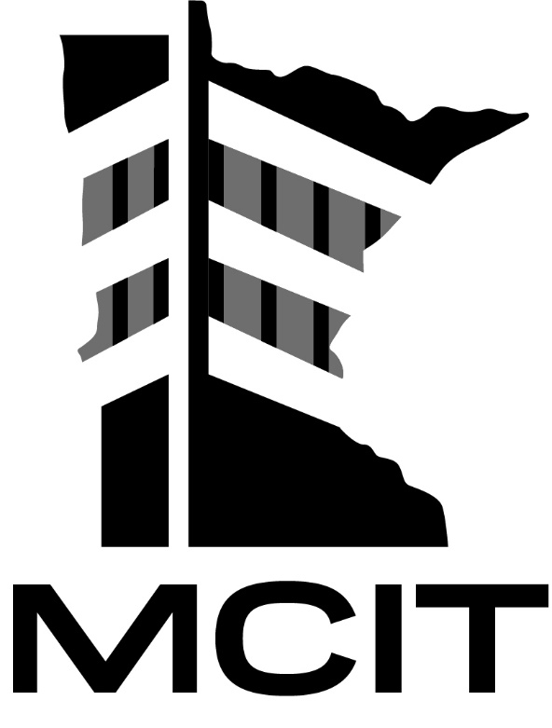
This document is intended for general purposes only and should not be construed as legal or coverage advice on any specific matter. Developed and provided by Minnesota Counties Intergovernmental Trust.

- If knives are equipped with safety features, such as a self-retracting blade, do not bypass these safety features. They are there to keep you and others safe.

- If knives are equipped with safety features, such as a self-retracting blade, do not bypass these safety features. They are there to keep you and others safe.

